USER GUIDE FOR THE CHATBOT
SNUBOT helps you to find where the items can be found in the supermarket.
There are 7 shelves in the supermarket.
You can find the following items in those shelves.
Shelf 1: apples, bananas
Shelf 2: onions, garlic, spinach, potatoes, tomatoes
Shelf 3: milk, butter, yogurt, cheese
Shelf 4: chicken, beef, fish, eggs
Shelf 5: detergent, soap, shampoo, towels
Shelf 6: rice, pasta, beans, bread, oats
Shelf 7: tea, coffee, chocolate
Sample inputs and outputs
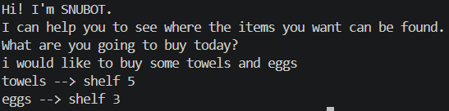
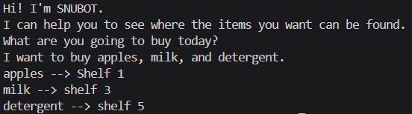
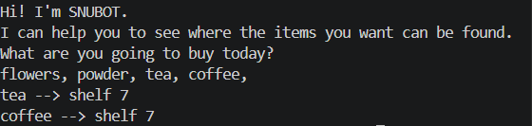
If you put an item which is not in the above list the bot will not show any output.
The chatbot is not case sensitive.

